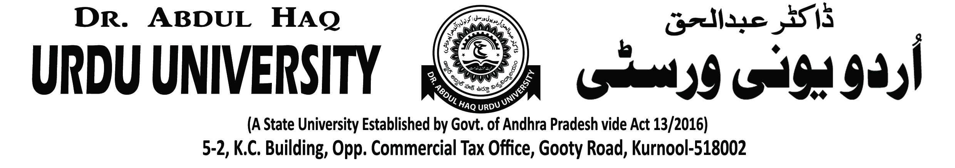

Dr. Abdul Haq Urdu University NSS UNIT

NSS unit organised an awareness programme on waste material recycle and management in University Campus on 01-08-2019. In this programme Honourable Vice-Chancellor Prof K.Muzaffer Ali, NSS Co-ordinator Dr.S Mahaboob Basha, University Principal in-charge Mohammed Irfan, Faculty Members and Students also participated.

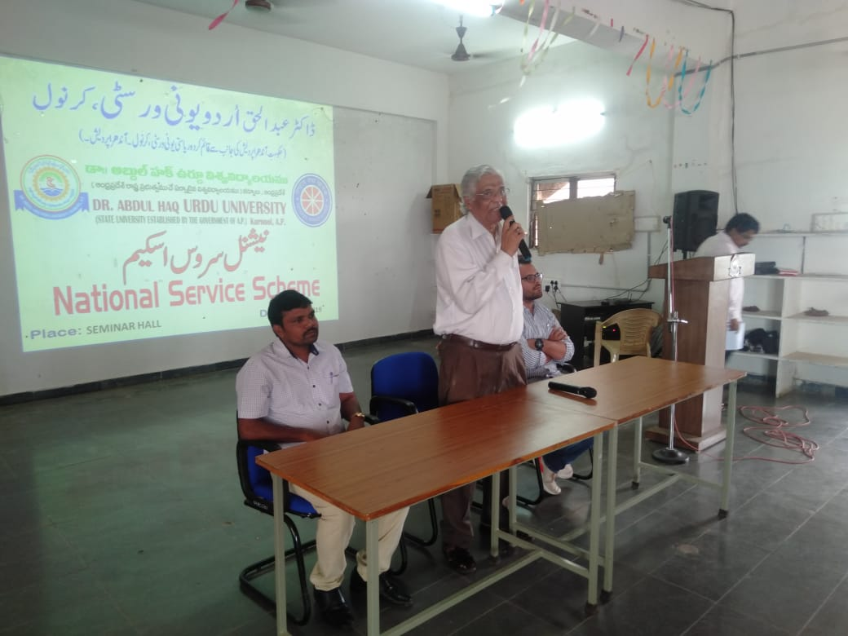 | 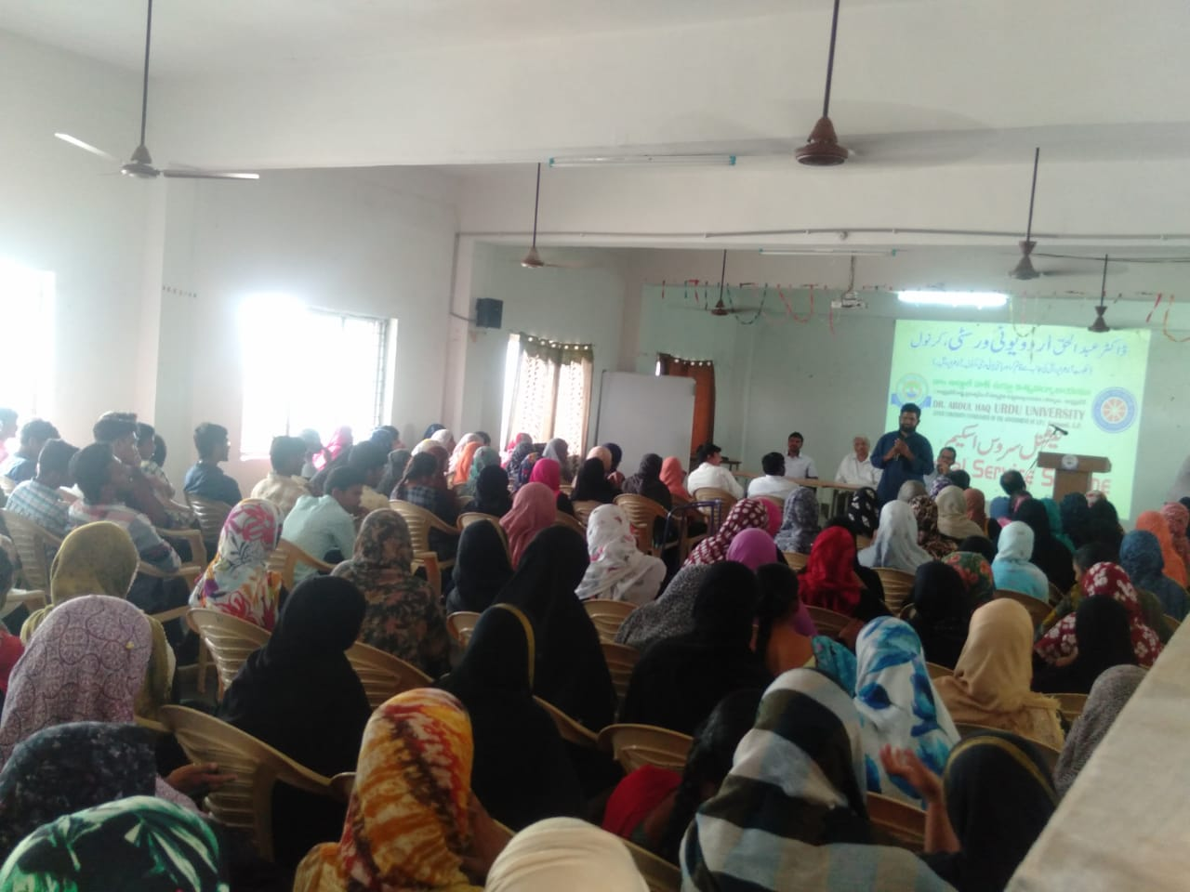
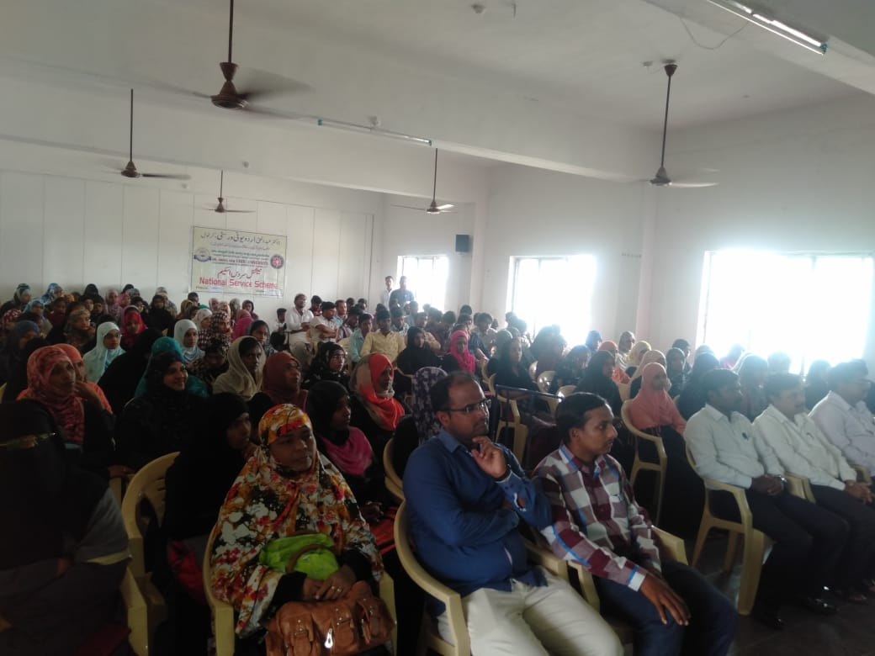 | 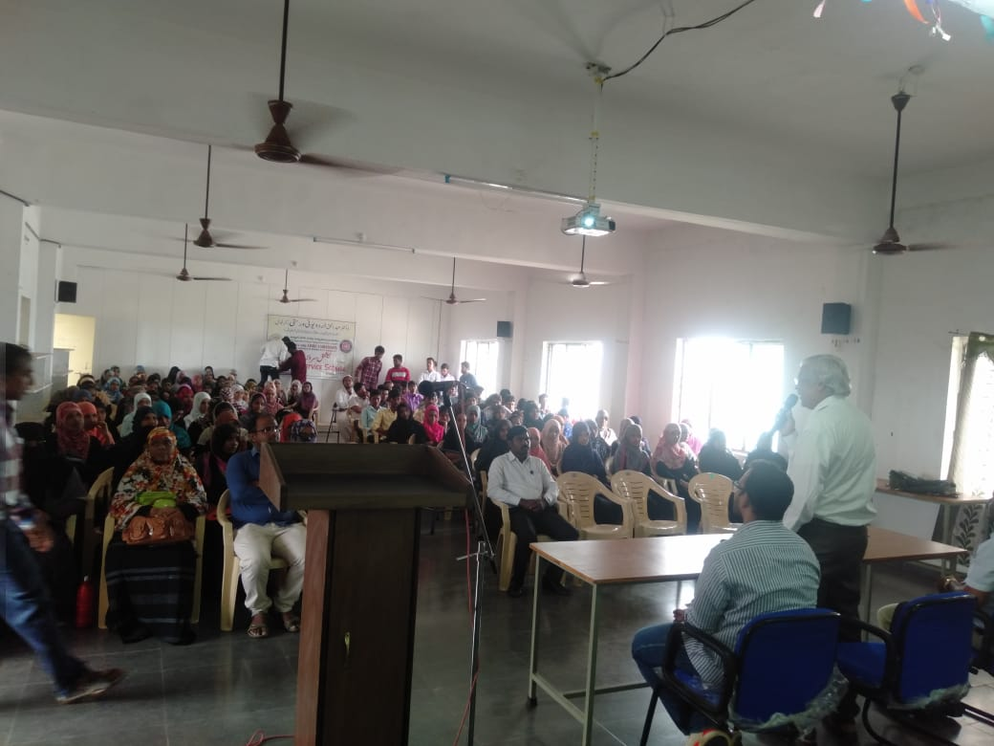
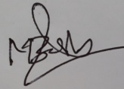

NSS Co-ordinator
(Dr. S.Mahaboob Basha)

